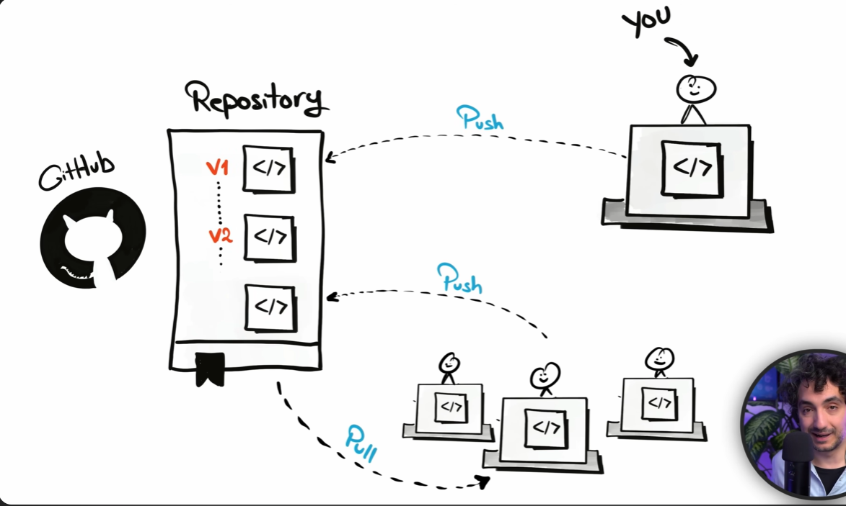

Below is the repo link:
https://github.com/Mukesh153/DE_PRACTICE/tree/main/sql-data-warehouse-project

